Information Security Lab 8
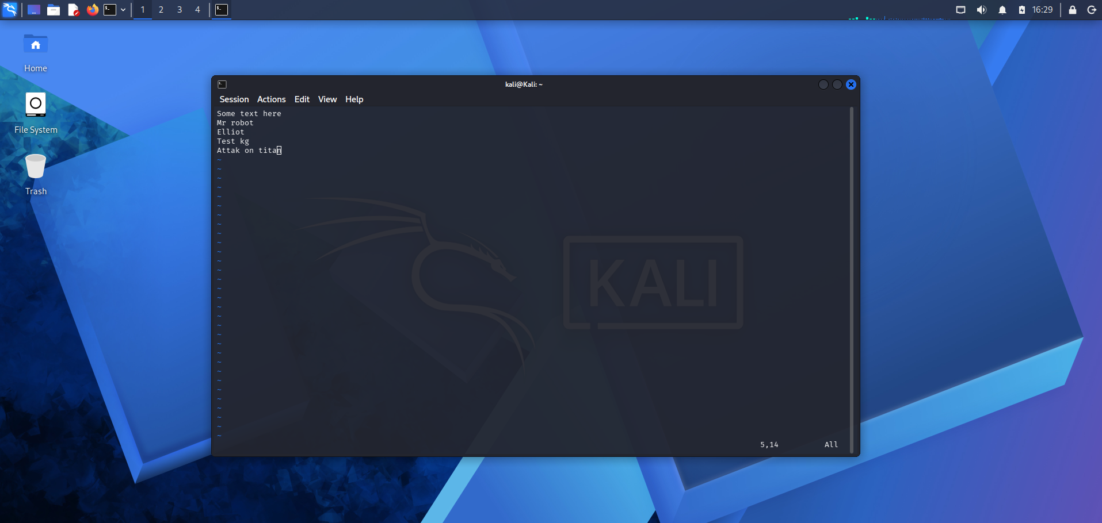

(kali㉿Kali)-[~]
└─$ sudo apt install vim
[sudo] password for kali:
The following package was automatically installed and is no longer required:
python3-mitmproxy-wireguard
Use 'sudo apt autoremove' to remove it.

Upgrading:
vim vim-common vim-runtime vim-tiny xxd

Installing dependencies:
libsodium26

Summary:
Upgrading: 5, Installing: 1, Removing: 0, Not Upgrading: 1968
Download size: 10.5 MB
Space needed: 1,293 kB / 41.5 GB available

Continue? [Y/n] Y
Get:1 http://mirror.ourhost.az/kali kali-rolling/main amd64 vim amd64 2:9.2.0858-1 [1,761 kB]
Get:5 http://kali.download/kali kali-rolling/main amd64 libsodium26 amd64 1.0.22-2 [210 kB]
Get:6 http://kali.download/kali kali-rolling/main amd64 xxd amd64 2:9.2.0858-1 [65.2 kB]
Get:2 http://mirror.yer.az/kali kali-rolling/main amd64 vim-common all 2:9.2.0858-1 [485 kB]
Get:4 http://mirror.yer.az/kali kali-rolling/main amd64 vim-runtime all 2:9.2.0858-1 [7,158 kB]
Get:3 http://mirror.ourhost.az/kali kali-rolling/main amd64 vim-tiny amd64 2:9.2.0858-1 [771 kB]
Fetched 10.5 MB in 6s (1,841 kB/s)
(Reading database… 426030 files and directories currently installed.)
Preparing to unpack …/0-vim_2%3a9.2.0858-1_amd64.deb…
Unpacking vim (2:9.2.0858-1) over (2:9.1.2141-1)…
Preparing to unpack …/1-vim-common_2%3a9.2.0858-1_all.deb…
Unpacking vim-common (2:9.2.0858-1) over (2:9.1.2141-1)…
Preparing to unpack …/2-vim-tiny_2%3a9.2.0858-1_amd64.deb…
Unpacking vim-tiny (2:9.2.0858-1) over (2:9.1.2141-1)…
Preparing to unpack …/3-vim-runtime_2%3a9.2.0858-1_all.deb…
Adding “diversion of /usr/share/vim/vim92/doc/help.txt to /usr/share/vim/vim92/doc/help.txt.vim-tiny by vim-runtime”
Adding “diversion of /usr/share/vim/vim92/doc/tags to /usr/share/vim/vim92/doc/tags.vim-tiny by vim-runtime”
Unpacking vim-runtime (2:9.2.0858-1) over (2:9.1.2141-1)…
Removing “diversion of /usr/share/vim/vim91/doc/help.txt to /usr/share/vim/vim91/doc/help.txt.vim-tiny by vim-runtime”
Removing “diversion of /usr/share/vim/vim91/doc/tags to /usr/share/vim/vim91/doc/tags.vim-tiny by vim-runtime”
Selecting previously unselected package libsodium26:amd64.
Preparing to unpack …/4-libsodium26_1.0.22-2_amd64.deb…
Unpacking libsodium26:amd64 (1.0.22-2)…
Preparing to unpack …/5-xxd_2%3a9.2.0858-1_amd64.deb…
Unpacking xxd (2:9.2.0858-1) over (2:9.1.2141-1)…
Setting up xxd (2:9.2.0858-1)…
Setting up vim-common (2:9.2.0858-1)…
Setting up vim-runtime (2:9.2.0858-1)…
Setting up libsodium26:amd64 (1.0.22-2)…
Setting up vim (2:9.2.0858-1)…
update-alternatives: updating alternative /usr/bin/vim.basic because link group ex has changed slave links
update-alternatives: updating alternative /usr/bin/vim.basic because link group vi has changed slave links
update-alternatives: updating alternative /usr/bin/vim.basic because link group view has changed slave links
Setting up vim-tiny (2:9.2.0858-1)…
Installing new version of config file /etc/vim/vimrc.tiny…
Processing triggers for kali-menu (2026.1.5)…
Processing triggers for desktop-file-utils (0.28-1)…
Processing triggers for hicolor-icon-theme (0.18-2)…
Processing triggers for libc-bin (2.42-13)…
Processing triggers for man-db (2.13.1-1)…

┌──(kali㉿Kali)-[~]
└─$ touch vim_test.txt

┌──(kali㉿Kali)-[~]
└─$ vim vim_test.txt

┌──(kali㉿Kali)-[~]
└─$ vim vim_test.txt

┌──(kali㉿Kali)-[~]
└─$

h j k l (navigate), x (delete char), dd (delete line), A (append at end), yy (copy line), p (paste), :wq (save and quit)

